#Report View Page
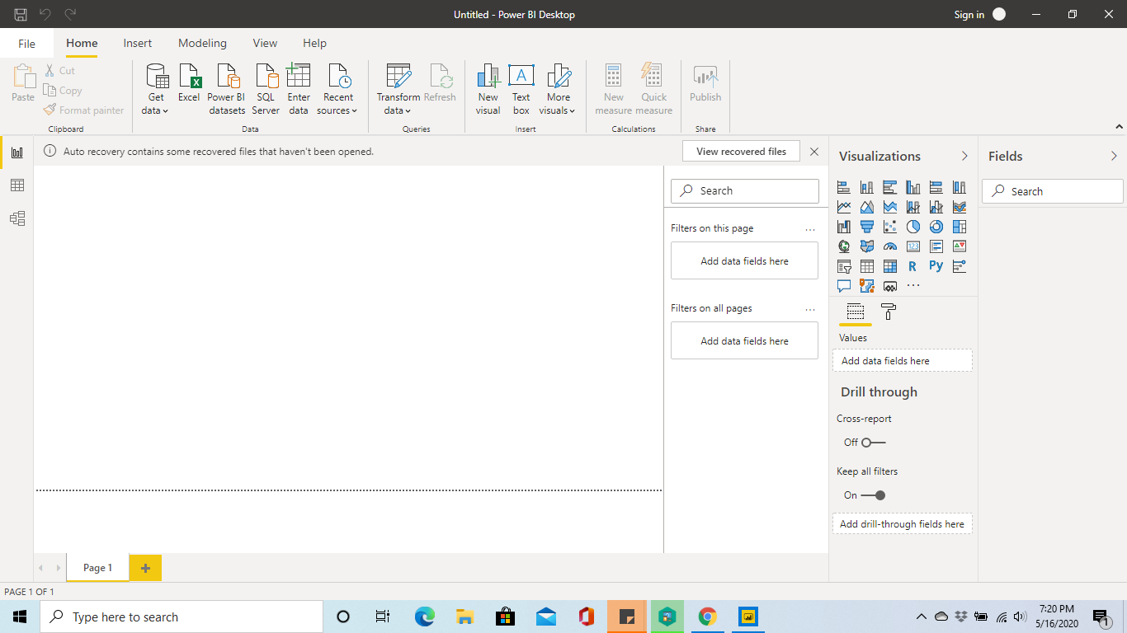

#Data View Page
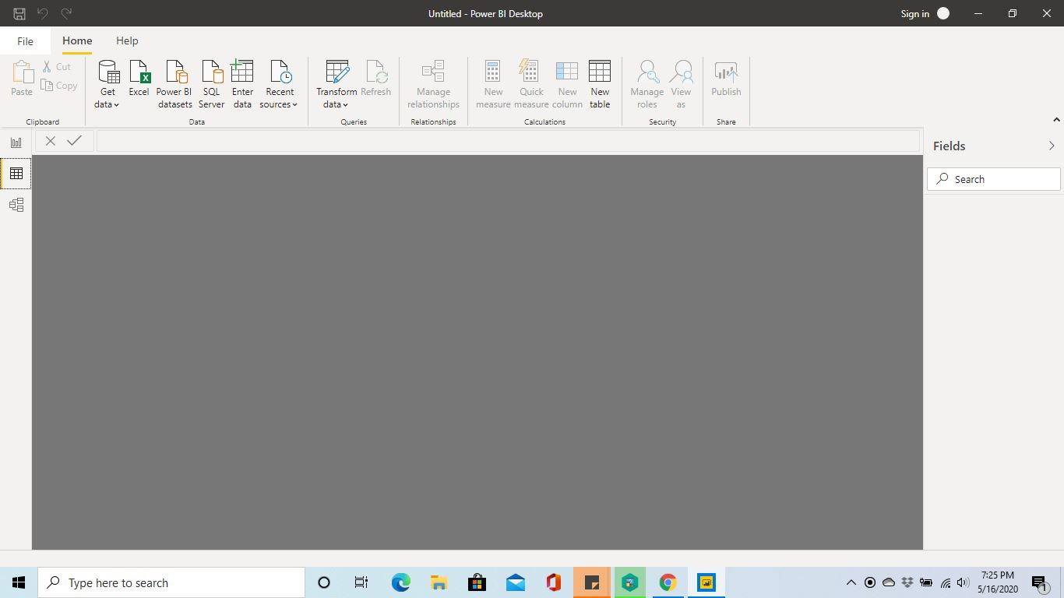

#Model View Page
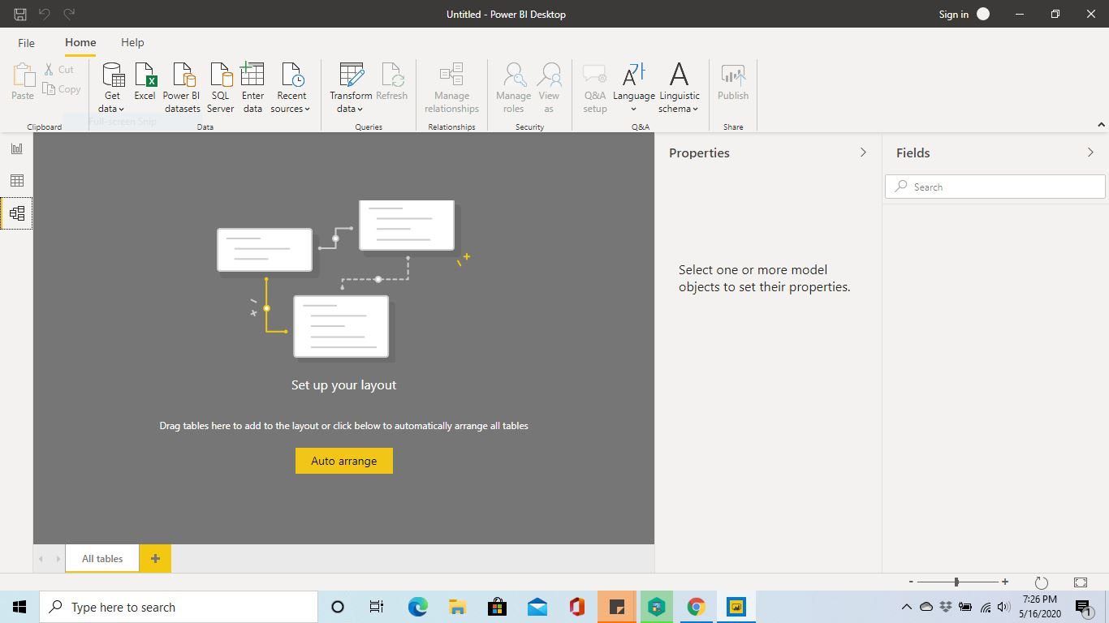
#Power Query Editor
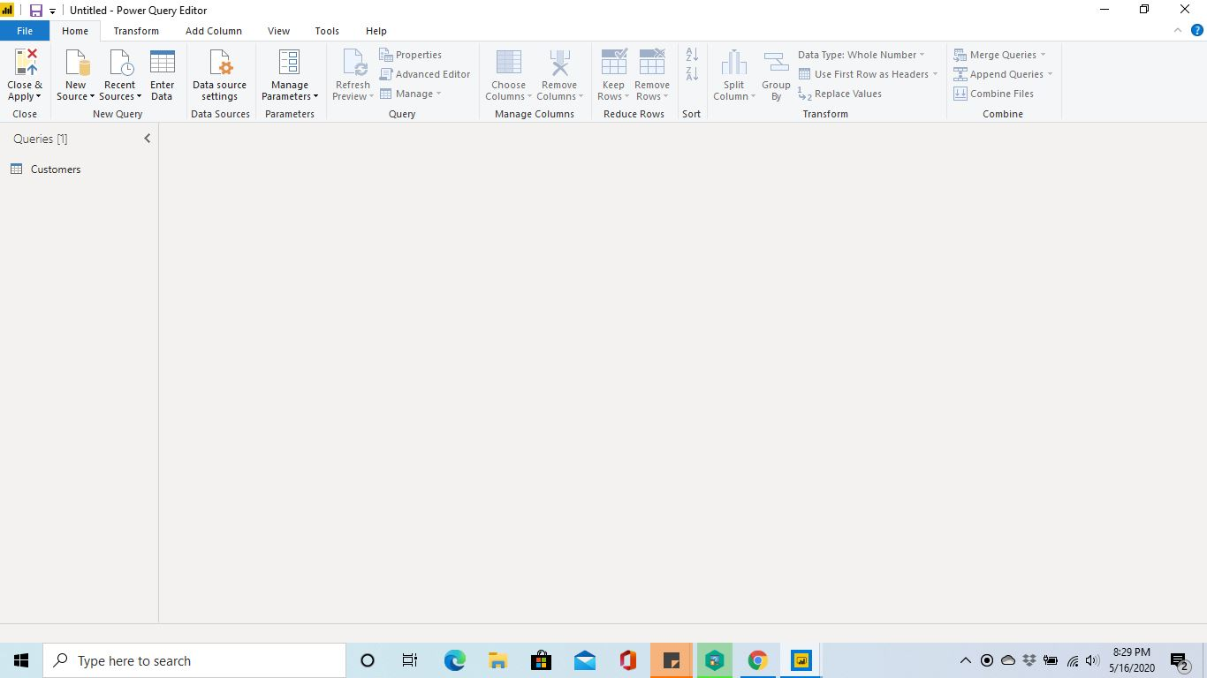

#Advance Editor
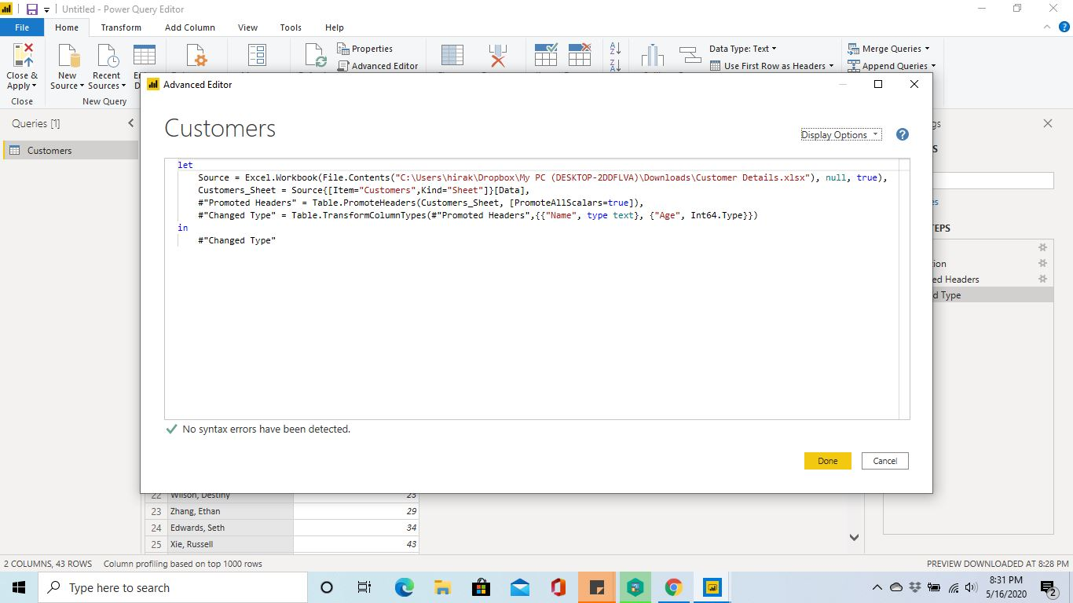
Power BI Desktop:
Power BI Desktop is free applications you install on your local computer that lets you connect to, transform, and visualize your data. With Power BI Desktop, we can connect to multiple different sources of data, and combine them (often called modeling) into a data model. This data model helps us to build visuals, and collections of visuals where we can share as reports, with other people inside our organization. Most users who work on business intelligence projects use Power BI Desktop to create reports, and then use the Power BI service to share their reports with others.
Price: Free

Power BI Pro:
Power BI Pro is an individual user license that lets users read and interacts with reports and dashboards that others have published to the Power BI service. Users with this license type can share content and collaborate with other Power BI Pro users.
Price: $9.99

Power BI Premium:
Power BI Premium is a capacity-based offering that includes: Flexibility to publish reports broadly across an enterprise, without requiring recipients to be licensed individually per user. Greater scale and performance than shared capacity in the Power BI service.
Price: $4,995

